\Image result for horse clip artImage result for horse clip artImage result for horse clip art

**Fire Department**

One lap around Pacific Union Field, then proceed to Janes Rd. through the parking lot

**Start**

**Parking Lot**

**1.5 miles**

**Finish**

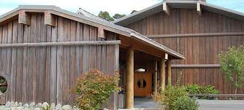

**PHV**

**Potawot Green Houses**

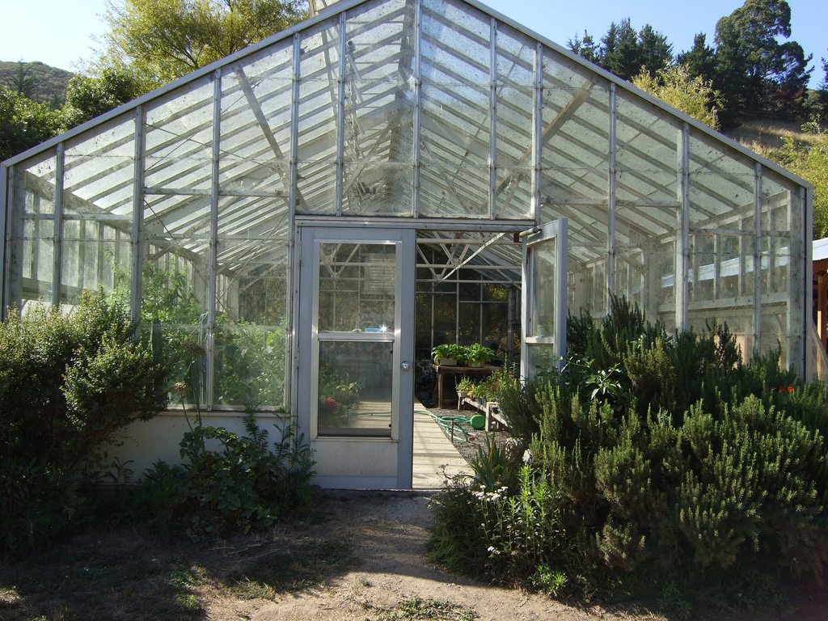

**Gravel Access Road**

**Potawot Trail**

**0.5 miles**

**Pacific Union School**

**Water Station**

**Start to finish =1.5 miles**

**Repeat course for full 5K**





**Janes Rd.**

**1 mile**

**Weeot Way**

**Mad River Hospital**

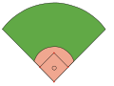

**Pacific Union field**

**Stay in The Bike lane oSpear Ave.**

28th Annual HAWC Walk 5k Run/Walk Route Map

fin